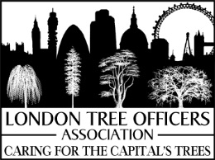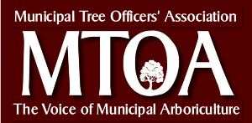

National Tree Officer’s Conference 2016 - Call for Papers Now Open

2 February 2016

The first National Tree Officer’s Conference is being organised by the London Tree Officers Association (LTOA) and the Municipal Tree Officers Association (MTOA)
and facilitated by the Institute of Chartered Foresters (ICF). The conference will provide an opportunity for tree officers to present to their colleagues on the latest research, best practice and innovation in different areas of local authority arboricultural work.

The conference will be held on the 9th November 2016, at the Oakengates Theatre, Limes Road, Telford, TF2 6EP (www.theplacetelford.com). Conference bookings will open later in the year at www.charteredforesters.org/tree-officers-conference

The submission period for abstracts is now open and will close on the 14th April 2016.

Abstracts are to be a maximum of 500 words and will be considered on a wide range of subjects that are relevant to the remit of a tree/woodland/planning officer. (Abstracts will only be considered from local government (LG)-employed tree officers and woodland officers.) For guidance, the following subject headings are suggested:

- Tree strategies/policy/tree database innovation
- Biosecurity
- Tree risk management
- Case studies – tree projects and or best practice
- Tree related planning and enforcement case studies
- Raising the profile of trees with the LG setting/working effectively with Politicians
- Tree planting
- Working well with the public/tree groups/forums/friends of groups

Abstracts will be reviewed by a selection committee (Russell Horsey MICFor, Matthew Seabrook, Al Smith MICFor, Jake Tibbetts) and selection will be based on overall quality, appropriateness, focus, and the practical nature of material and appeal to a tree officer audience.

We look forward to seeing you at the conference, and receiving a wide range of abstracts.

Submissions by email to: Becky Porter, London Tree Officers Association executive.officer@ltoa.org.uk.

